Being Things/ I am a … (Personification) Poems
Personification Poems are types of verse in which inanimate or non-human objects are given human attributes. This type of poetry uses figures of speech in which things or animals are given human characteristics which we recognize in ourselves.
Example, "I am a broken air conditioner wheezing with pain."
Wheezing and pain are typically human conditions associated with a blockage within our respiratory system. The comparison helps us to understand that part of the problem with the malfunctioning air conditioner is that it is making funny noises. The pain aspect helps the reader to empathize with the air conditioner, because in all likelihood the reader has suffered a similar fate and can "feel" for the machine.
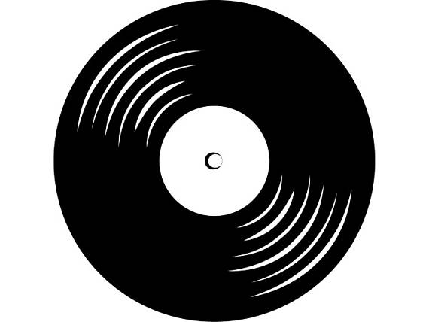
Examples
I am…
I am an album
I stress that I will only be a one hit wonder.
I hear critics pointing out the flaws in my songs and I feel scrutinized.
I want to make a difference, so I pretend that those who detract from my dreams are irrelevant.
I feel scratched – physically and emotionally.
I touch minds around the world, yet I worry the “in” crowd won’t listen to me.
I understand my artists.
They say what I feel in my soul.
I dream to be a world-wide sensation and have my face on the cover of every magazine.
I try to please my listeners, and I aspire to someday go double platinum in sales.
I am an album.

I am …

I am an airplane
I ponder my upcoming destinations as I hear my engines roar to life on the tarmac.
My greatest desire is to continue to journey where the sky is the starting point - not the limit.
In times of loneliness the clouds are my friends.
I pat them with the tip of my nose and my wings.
At times I feel bloated by the passengers and suitcases that pack my insides.
I worry that I may disappoint these travelers as I rock to and fro with the turbulence.
However, I appreciate that unexpected obstacles and weather will shake up my flight.
I expect they do too.
At the onset of each voyage I psyche myself up to perform flawlessly.
But I must be realistic. No one is perfect!
I pray that each landing will be as smooth as the journey that got me there.
I am an airplane.

Assignment Criteria
- You are to complete two “Being Things – Personification” poems.
- Each poem must be a minimum of 10 lines (that includes the first line – “I am a…”
- Each poem should contain a minimum of 6 appeals to personification

