[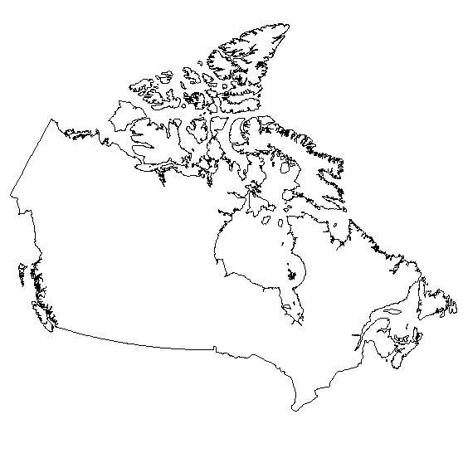](http://geography.about.com/gi/o.htm?zi=1/XL&zTi=1&sdn=geography&cdn=education&tm=20&gps=385_324_1362_596&f=00&su=p284.12.336.ip_&tt=0&bt=0&bts=0&zu=http%3A//0.tqn.com/d/geography/1/0/T/K/canada2.jpg)