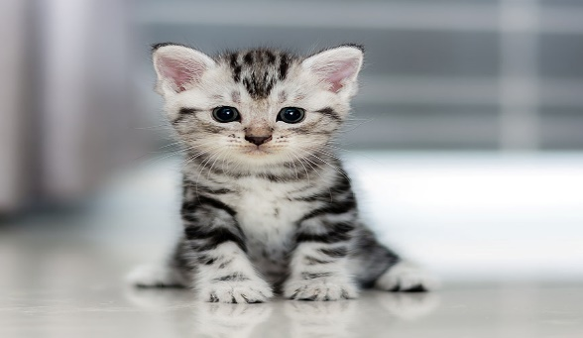
Kittens
Fun to cuddle with
Purr when happy and wag tails
Scratch skin with their claws

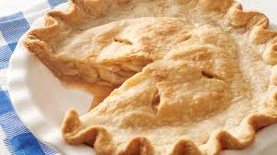
Apple Pie

Smells great when baking
Crust and sugar tastes superb
Burns mouth when too hot

Lightning

Rattles the windows
Spooks children, pets and grandma
Lights up the dark sky.

