Onomatopoeia Example
Smack!
The yellow-green globe compresses against the tightly wound strings of the racket.
Bounce! Swoosh!
It reflects off the hard court surface regaining it’s form as it soars in desperation through the air.
Scrape!
The friction created by the athlete’s shoes slide as he reaches for a desperation save.
Oof! The wind escaping from his outstretched lungs, and Drip! the perspiration trickles from his brow.
Gulp!
The net swallows the globe.
Ahhhhhh!
The crowd reacts, then Hooray! as the line judge roars: “Out!”.

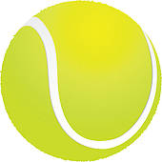
Game. Set. Match.

Smack!
The yellow-green globe compresses against the tightly wound strings of the racket.
Swoosh! Bounce!
It reflects off the hard court surface regaining it’s form as it soars in desperation through the air.
Scrape!
The sound of friction created by the athlete’s shoes slide as he reaches for a desperation save.
Oof! The wind escaping from his outstretched lungs, and Drip! the perspiration trickling from his brow.
Gulp!
The net swallows the globe.
Ahhhhhh! The crowd reacts.
Then Hooray!
The line judge roars: “Out!”.

