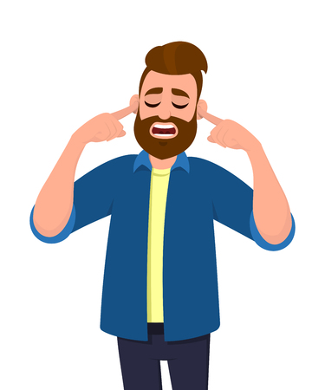
An Assault to the Ears
When given time to work on their homework this 8-2 class sounds like…
A swarm of bees buzzing around a honey nest.
Continuous thunder crashing during a violent summer storm.
The hollering wind of a tornado whipping against the exterior of a house.
A dump truck emptying its contents onto a gravel road.
A lion’s roar after being threatened by a challenger in the wild
A jackhammer smashing concrete into tiny stones
The New York Philharmonic Orchestra practicing with their instruments out of tune.
The blast from a thousand cannon balls being released at the exact same time.
A flock of squawking seagulls on a harbor front fighting over a scrap of fish guts.

Pure Joy and Happiness
The joy and happiness I feel when the 8-2 class accomplishes a goal feels as good as…
My favorite team coming back to win the Super Bowl after being down 21 points at half.
Drinking a glass of hot chocolate after shoveling the driveway following a winter’s storm.
Finding a lost item that has been missing for months.
Reaching into a pocket of an old pair of jeans and finding a $100 bill.
Attending a family reunion and seeing relatives that you haven’t seen in years.
Opening presents on Christmas morning.
Having my teeth cleaned at the dentist and having no cavities.
Completing a great novel in which the main characters have all their dreams come true.

