Simile Poem
A simile is an easy way to compare two things, so examples of simile poems include any poem that makes comparisons using the words "like," or "as." As long as you compare one thing to another, whether or not the two things you are comparing are actually alike or not, you can consider it a simile poem.
Examples of similes include: “as white as snow” or “falling like drops of rain.”
The following are examples of simile poems:
Smiles A Nasal Passage Assault
A smile from someone you love creates joy like... The inner hold of my bedroom smells like…
A rainbow after a downpour Burning plastic
A sunset full of vibrant color Aged decaying fish
A whiff of rain after a summer drought A wet burlap sack
Smooth silk under your fingers A moldy apple’s death
A parent's embrace after you have a nightmare Freshly laid carpet glue
A dove flying over a tranquil sky A skunk forced to defend
Hearing your favourite C.D. Ground thawing in spring
A finished work of art A hospital’s sterile environment.
A glass of warm cocoa after a cold day in the snow
A piece of triple berry pie
Receiving an "A" on a test
Completing a fabulous book
The last piece of a puzzle
The phone call you've been waiting for
A clean sheet of paper waiting to be written on
Sleeping in after the busses have been cancelled.

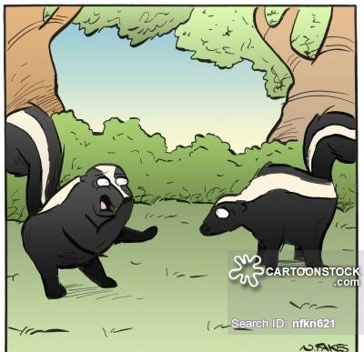

The poem shown here is an example of a more advanced type of simile poem. Notice how the simile is used in one line and then explained in the next line. It also rhymes, which is not a mandatory component of this type of poetry.
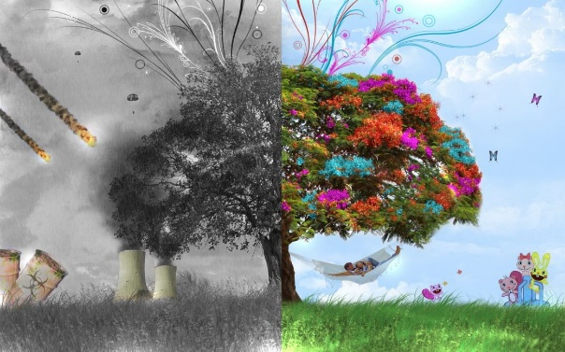
War and Peace
By Cam T.
War is like a fire,
Burning through memory.
Peace is like a puzzle,
Confusing, tough to complete.
War is as dark as murder,
Killing every day.
Peace is like a dove,
Flying free, yet not leading the way.
War is like power,
Peace is like hope.
War is like destruction,
Peace is like the ability to cope.
War is like a nuisance,
Worse and worse with age.
Peace is like a lion,
Majestic but trapped in a cage.
Peace is like an old toy,
Left in the basement to rot,
It sits there crying softly’
Its throat tied up in a knot.
My mind forces me to war,
But my heart desires peace.

Assignment Criteria:
- You are to complete 2 Simile poems.
- Each poem must be a minimum of 9 lines – this includes the first line in which you identify what you will be comparing things to throughout the length of the poem

