Western Rights and the Beginning of the Red River Rebellion

Use pages 129-135 of the Canada Through Time textbook to help you to answer these questions.

- What main groups of people lived in the West in 1867?
______________________, _______________________, ______________________

- Why were the Metis and some other inhabitants against having more new settlers in the Red River area? Provide 2 reasons.

- Background Louis Riel (Metis Leader) –
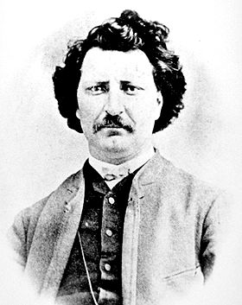
a) Where did Riel attend school in his early teens? _____________________
b) What was Riel training to become? _____________________________
c) List two of the hardships faced by students at the seminary in Montreal.
________________________________, ____________________________
- When Riel was 21 he left the seminary and went to work at a _________ office.

- What “racist” event happened in Montreal in 1866 that left Riel feeling disappointed and mistrustful of “white” Canadians?
_____________________________________________________________________________

- When Riel returned to the Red River Settlement it was not as he had left it 10 years before. List 3 hardships that the Metis had endured over that decade.
________________________, ________________________, ___________________________

- a) Why was Canadian Prime Minister John A. MacDonald interested in buying the vast area between the Eastern provinces and British Columbia?
- When he became Prime Minister he had guaranteed British Columbia a ____________________ link to the eastern Canadian provinces in exchange for joining _________________________.
- He was worried the ________________ ___________________ would move into this huge land area and take it over before Canada.

- In response to his anxiety about the U.S. expansion, the Canadian government sent ______________ into the Red River area to start marking the land into _____________ sections for new settlers.

- In October of 1869, a conflict between the Metis and the Canadian government took place on the hay privilege of ___________ ______________ (Louis Riel’s cousin). In defiance of this intrusion onto their land, Louis Riel led a patrol and stood on the survey ____________ and ordered the surveyors to __________________. Riel demanded a negotiation with the Canadian government before the Metis would join Canada.

- Use page 134 of the textbook to fill in the spaces provided in the chart below.
The Beginning of the Red River Rebellion
Summarize the actions of the Canadian Government appointed leader of the North-West in 1869 and the subsequent response of the Metis “National Committee of the Metis” in the organizer below. How did the actions that McDougall took anger the Metis and other settlers already living in the Red River Settlement?

What McDougall Did | How the Metis Responded
- Approached the North-West by way of the United States | 1. Wrote a letter to McDougall ordering him not to enter the North-West
2. | 2.
3. | 3.

William McDougall National Committee of the Metis
(Lieutenant Governor of North West
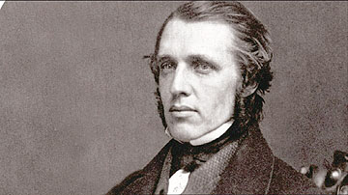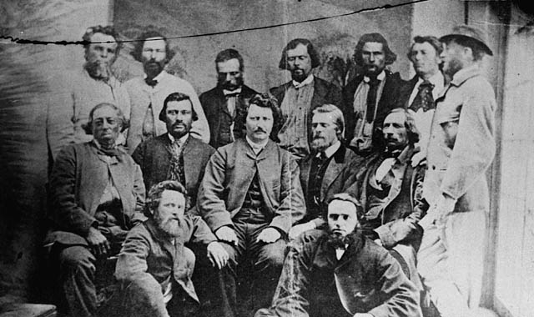
Canadian Flag 1870 Metis Flag
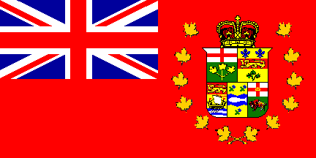
Fort Dufferin Fort Garry
(Abandoned Hudson Bay Company Post) (Hudson Bay Company Post)
Located North of Red River Settlement (Located within Red River Settlement
