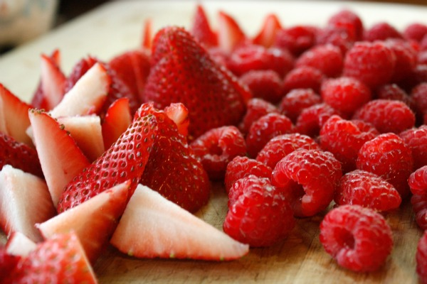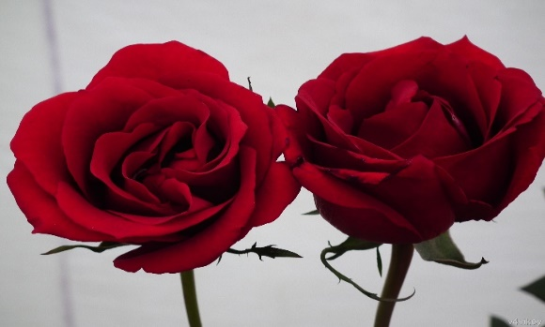

**Red Means Love**

Red is the sign of love

Red is the color of blood

Red is the color of Christmas

And the color of Rudolph’s shiny nose

Red tastes like Frank’s Red hot sauce sizzling in my mouth

Red smells like freshly planted roses in the garden

Red sounds like fire truck sirens on their way to put out a fire

Red feels like a stress ball being squished

Red looks like ruby stones

Red makes me think of Valentine’s Day

Red is the color of strawberries and raspberries

Red is pinks mother

Red reminds me of our Canadian flag

Red is my favorite color

By :Jack Mayotte