Creature Alliteration Poem
This type of poem makes use of alliteration to describe an imaginary creature. It is a humourous, whimsical form of poetry. The main words in each line will all begin with the letter you choose to alliterate. Each line of the poem (except line 1) should have at least 4 words alliterating with the letter you choose. Do not repeat alliterating words you have already used.

Directions:
Line 1: Name your creature (for example add –ian to the end of the word)
Line 2: Write 4 alliterating words about where your creature lives
Line 3: Write 4 alliterating words about what your creature eats
Line 4: Write 4 alliterating words about what your creature likes
Line 5: Write 4 alliterating words about something else about your creature
Line 6: Write 4 alliterating words about something your creature did to you

Examples:
This is a Teacherian
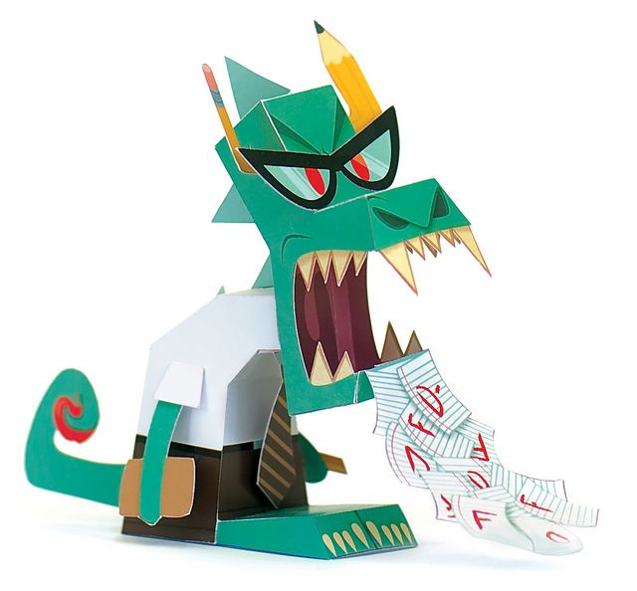
Teacherians live on truly terrible terraces in Texas.
Teacherian tend to treat themselves to trifle, turkey and treacle – together!
Teacherian like travelling, talking, trustworthy teenagers and turquoise tinsel.
Teacherian typically tread on trails on Tuesdays together in triplets.
Treasure troves test Teacherians trustworthiness.
Teacherian tricked me with a Turkish tablet and trapped me in a temporary Thai Temple.

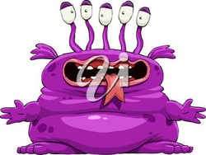
This is a messitarian
A messistarian lives in a messy moat mixed with mashed mushrooms.
A messitarian eats messed up moldy milk mixed with Mexican Mushroom munchies and Mountain Dew.
A messitarian likes to visit Madagascar, multiplying in Math, Messi and Mount Pakenham.
A messitarian must mash mangos at midnight.
My messitarian messed up my mom’s marvelous mountain bike.

