Doodle Leaf Design Elements
1. Symmetry is when a shape or object has two completely identical sides that are either f acing each other or are around an axis.
A line of symmetry is the line that divides the two identical parts, each part being a mirror reflection of the other.

Examples

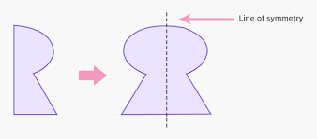

2. A design is a plan for the construction of an artistic piece. A good design makes it easy for the viewer to interpret the intended message of the artist.

Examples

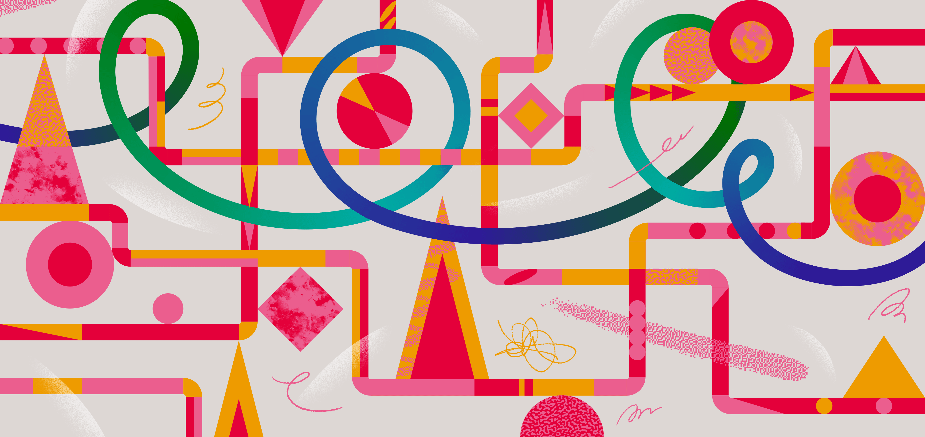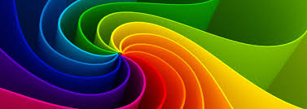

3. Harmony in art and design is the visually satisfying effect of combining similar, related elements.

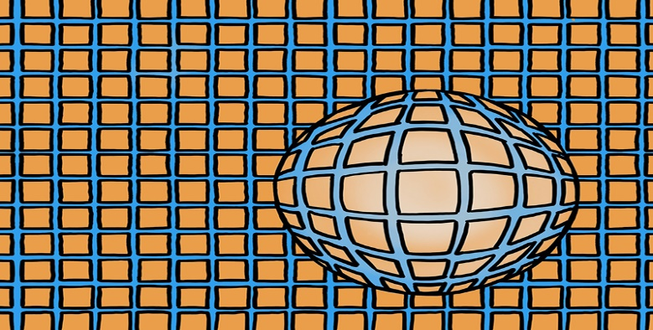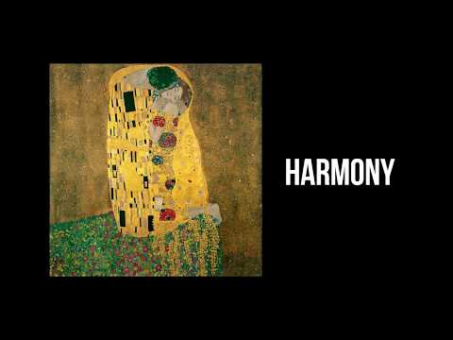
4. Rhythm in art refers to the arrangement of shapes in a way which creates an underlying beat. It is similar to the rhythm of music, but instead of notes and sounds, we use colors and shapes.

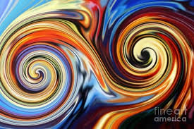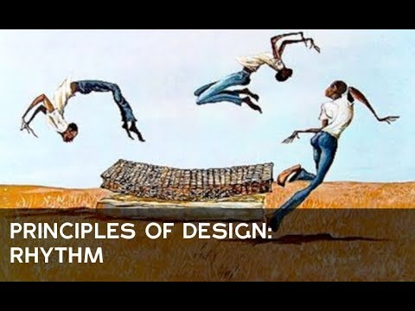

Types of Lines

