Maintaining Proper Tense When Writing a Narrative: News Story
Fill the gaps with a suitable tense form of the verb in brackets.
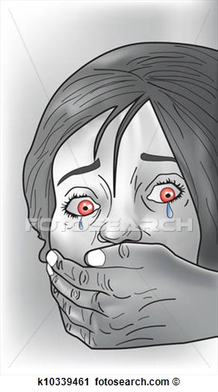
In Nigeria, a three-year-old British girl ___________________ (reunite) with her parents after being freed by kidnappers in southern Nigeria who___________________ (hold) her for four days. Margaret Hill's parents, Mike and Oluchi Hill, said she was in good health but "covered in mosquito bites".

The kidnappers ___________________ (threaten) to kill the girl unless a ransom ___________________ (pay) or Mr. Hill ___________________ (take) her place. Mr Hill, an oil worker, ___________________ (say) no ransom ___________________ (pay). He told Sky News that his daughter ___________________ (return) "in a little bit of a trance", but soon began coming back to life and talking to her mother. The child ___________________ (hold) "in the bush... in some sort of hut", he said. "I don't think she had much to eat because she is hungry now."

Margaret ___________________ (snatch) on Thursday morning when gunmen ___________________ (smash) the window of a car driving her to school in Port Harcourt as it stood in traffic. The car's driver __________________ (stab) as he tried to protect the girl.

Her Nigerian mother, Oluchi Hill, later ___________________ (say) the abductors ___________________ (contact) her and ___________________ (demand) an unspecified ransom for Margaret's release. The kidnappers ___________________ (vow) to kill the girl unless her father, a British expatriate oil worker originally from Murton in County Durham, took her place.
Our correspondent says more than 200 hostages ___________________ (take) by armed groups in the last 18 months in Nigeria, but none has ever been killed.

