Poetry Writing #1 – Create 3 Riddles

What is a Riddle?
A Riddle is a type of poem that describes something without actually naming what it is, leaving the reader to guess. It involves the reader in considering a series of clues to help them to eventually arrive at a logical answer.

Riddles can be about anything (from animals to objects).
- There are no formal rules on how to structure a Riddle poem
- Riddles can be funny (although they don’t have to be) or they can rhyme (although they don’t have to), it depends on the person writing the Riddle and what they are comfortable with.

Example of a Riddle (no rhyme) Example of a Riddle (rhyming)
It is an animal I come in different styles
It is orange and black I can help you walk for miles
It has stripes I come in a pair
It has four paws I’m something you wear
It lives in the jungle With heals I am glam
What am I? Can you guess what I am?
Guess = _____________________ Guess = ____________________

Create Your Own! Here’s How!

Step 1 – Choose a topic
Riddles can be about anything you can imagine, but physical objects that people are familiar with are the most common topics (pencils, purses, flowers, scissors etc.).
- Other topics are natural phenomena (lightning, snow, wind, etc.) or an animal (cats, dogs, birds, elephant etc.).
- Avoid topics that are very abstract or require specialized knowledge.

Step 2 – Length of Riddle
Riddles can be very short or very long.
In grade 8, the minimal length will need to be 4-5 lines. The clues for your riddle should start off very generally and gradually become more specific as you approach the end. Your last clue should be the most obvious of the clues.

Step 3 – Start with the Answer
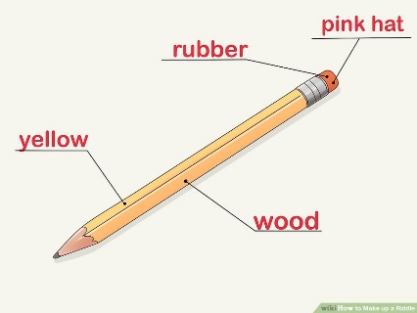
Once you have the solution of your riddle, you will work backward to create the riddle.
- For example, you could choose "a pencil" as your solution, because most people will be familiar with it.

Step 4 - Think of the things your answer does and what they look like.
Compile these ideas in a list. Try to think of verbs and adjectives, in particular. Think of synonyms with multiple meanings and write them down.
- For "pencil," some items for your list could include: "No. 2" (the most common type of writing pencil), "wood," "rubber," "yellow," "pink hat" (the eraser), "looks like the letter 'l' or the number '1'" (physical aspects of the pencil's shape).
- You could also include other aspects of your pencil: for example, “it needs to be sharpened as it writes” which means it will get shorter over time the more it's used (a possible paradox).
- Another common trick is to think of things your item can do: for example, “a pencil is small but contains all things” (because you can write "all things" with a pencil).

Step 5 – Draft Your Riddle
Riddles use metaphors to describe familiar things in unfamiliar ways. Think about the list of ideas you created in the last step. If your solution is “pencil,” think of words you could use to offer clues to the solution without giving away the answer.
Example
A golden sword
That wears a rosy hat
It is two trees
Both Number 1 and Number 2
An implement that unlocks the mysteries of the universe to those that put it to use.

- The pencil is a "sword" because it is pointed sharply at one end. This description also plays with the common saying, "The pen is mightier than the sword," and may help provide a clue. The "rosy hat" refers to the eraser.
- The "two trees" are cedar (the most common type of wood used for pencils), and rubber (the type of tree that produces rubber for erasers).
- The pencil looks like the numeral "1" but is actually a "#2" pencil. This description is a double pun, because the #2 pencil is actually the most common, or "number one," type of pencil.

Step 6 – Use Simple Strong Words
Try not to bog down your riddle with elaborate words or abstract concepts.
- For example, a simply worded riddle involving a pencil could be:
I wear a rosy hat
But have no head
I’m sharp but have no brain
I can say anything,
But will never speak a word.

Step 7 - Share your riddle with friends.
The best way to know if the riddle you’ve made works is to share it with your friends and family and ask them to guess the answer.

Assignment
Your task is to create 3 riddles to include in your poetry anthology. You have the option of including some pictures with your clues to help the reader solve your riddles, but this is not mandatory.

For practice, here is a weblink to some example riddles to try and solve on your own:
“Riddles with Answers for Everyone” - https://www.riddles.nu/poem-riddles/

