Created Sexual: Male and Female
Topic 4 Young People: In Relationship

Total = 19 marks

Introduction – pages 83-85

1. At what age do you think adolescents (ages 14-18) should be allowed to go out (date) as a couple by themselves? (1 mark)
____________________________________________________________________________________________________________________________________________________________

2. What is an infatuation (crush)? Do people sometimes have a crush on someone they don’t even know? (2 marks)
__________________________________________________________________________________________________________________________________________________________________________________________________________________________________________

3. What’s the difference between an infatuation and a relationship? (1 mark)
____________________________________________________________________________________________________________________________________________________________

4. Is it important for parents to have rules about when adolescents can go out as couples? Why or why not? (2 marks)
____________________________________________________________________________________________________________________________________________________________
______________________________________________________________________________

5. In your opinion, do you feel that there are a lot of pressures to get involved in exclusive male-female relationships or engage in sexual activity? Why or why not?
(2 marks)
__________________________________________________________________________________________________________________________________________________________________________________________________________________________________________

External Pressures on Young People – pages 85-87
1. How does media have a negative influence on young people’s views of male-female relationships and sexual intimacy? (1 mark)
____________________________________________________________________________________________________________________________________________________________

2. What’s odd about the results of the survey “Teens, Sex and TV”? (1 mark)
______________________________________________________________________________
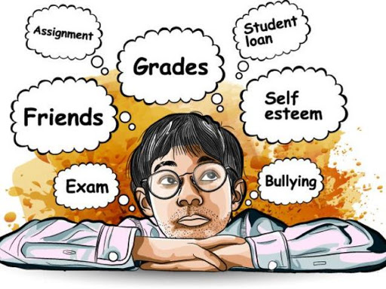
3. What might be the reason for these survey results? (1 mark)
___________________________________________________
___________________________________________________

4. What is your reaction to Chelsea’s story? (1 mark)
___________________________________________________
___________________________________________________

5. In what ways do you think her pregnancy changed her life? (1 mark)
______________________________________________________________________________

6. Describe your reaction to her boyfriend’s behavior. Identify a thing he could have done to better support her. (1 mark)
______________________________________________________________________________

7. What is wrong with pressuring other people about having a boyfriend or girlfriend? (1 mark)
______________________________________________________________________________

Part B – Internal Pressures – pages 87-89
1. How does getting involved in sexual activity to get attention or to feel appreciated end up hurting that person? (2 marks)
__________________________________________________________________________________________________________________________________________________________________________________________________________________________________________

2. Define what is meant by a “risky decision”? List 2 examples of risky decisions. (2 marks)
__________________________________________________________________________________________________________________________________________________________________________________________________________________________________________

3. Why are people more likely to make risky decisions when they are under the influence of alcohol or drugs? (2 marks)
__________________________________________________________________________________________________________________________________________________________________________________________________________________________________________

4. What’s wrong with sexting? Why do people sext? (2 marks)
__________________________________________________________________________________________________________________________________________________________________________________________________________________________________________

5. What is wrong with pressuring another person for sexual intimacy? (1 mark)
______________________________________________________________________________
Part C – Sexual Abuse – page 90-91
1. What does assault mean? (1 mark)
______________________________________________________________________________

2. Why are most sexual assaults made by a person known to the victim rarely reported?
(1 mark)
______________________________________________________________________________

3. Identify a risk for a young person who starts dating early and with an older adolescent.
(1 mark)
______________________________________________________________________________

4. Why is sexual abuse of children by adults so horrifying? (1 mark)
______________________________________________________________________________

5. What can we do for children and young teens who have been sexually abused? (1 mark)
______________________________________________________________________________

6. What should you do if you found out that a child or young person was being sexually abused?
(1 mark)
______________________________________________________________________________

7. What is so important about friendship for people your age? (1 mark)
_____________________________________________________________________________________

8. How does sexual attraction get in the way of developing a friendship with someone of the opposite sex? (1 mark)
_____________________________________________________________________________________
Main Themes of Young People in Relationships
Place the words below into the correct blanks to review the main ideas of this lesson.
(3 marks)
exclusive internal friendships develop pressures external

- Sexual attraction is a new experience for young adolescents. There are many ____________ on them to act on their feelings and become involved in ____________ male-female relationships at an early age.

- Some pressures on young people are ____________, such as media and peers. Others are ____________, such as unmet needs for attention, love, and acceptance.

- It is important for young people to begin to form healthy ____________ with people of the opposite sex and to value this stage of life as an opportunity to ____________ all aspects of themselves.

