Treaties with the Natives
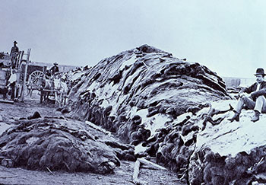
Use the class website and the textbook (pages 140-143) to answer the following questions>

- What had happened to the once thriving buffalo herds in the southern plains by the 1870’s? ___________________. This was caused primarily by: a) ______________________________________,
b) _______________________________________ and
c) _______________________________________
- Another major problem faced by the Native people was ________________________. American whiskey traders supplied the Native peoples with a strong mixture of alcohol called _____________ ______ ___________. The Natives were unfamiliar with the dangers of alcohol and ______________ ____________ became a major problem.

- In order to survive (starvation and alcohol abuse) some Indian leaders agreed to make arrangements with the Canadian government for use of their lands for _______________ by non-Natives. In return the Natives would receive __________ payments and other benefits. _______________ of land would be set aside, where Natives would be able to live “safely” and “undisturbed”.

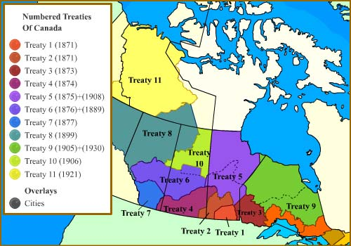
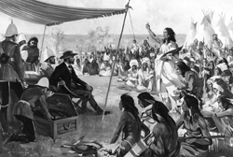
- Beginning in 1871, the government negotiated a number of ________________ with First Nation leaders of the North-West. Although some chiefs were willing to sign the agreements, some were not including Plains Cree chief Big ________.

Key Questions to Consider
*** Answer the following Activity questions on page 144 of the textbook #13a, 14a-b and 15. ***

